Company Profile

GSI Builders, Inc. is a Latino Owned Business and COBID certified with the State of Oregon as a MBE/ESB. We remain committed to advancing racial equity and creating a more inclusive Latinx and BIPOC community. GSI Builders is a commercial construction company based in Portland, Oregon. While our primary focus now is on affordable housing our past experience includes successful completion of a diverse variety or projects that range in value from under $100,000 to over $26,000,000, including affordable multi-family housing, market rate multi-family housing, commercial, industrial, retail, public works and tenant improvements.

We bring a long history of family values to each project we build. GSI Builders is a new business entity. I founded GSI Builders, Inc. in late 2018 with my father, Steve, who made the decision to leave Seabold Construction about 8 years ago. While we each temporarily pursued other interests, we still had a desire to create and grow a new company into an even better version of the old company. Currently, there are no ties between the two companies. My mother, Lina Garcia Seabold, also helped launch GSI Builders, Inc. As Owner/Secretary, she brings years of experience and a unique and valuable perspective to our team. Lina has longstanding ties in the local Latinx and BIPOC community and is a well-respected Leader.

In addition to the success and experience that Steve, Lina and I bring to each project, we have assembled a seasoned team of construction professionals who have not only worked with me directly but have successfully completed projects in all commercial construction markets. Currently, we are in the design and pre-construction phase for the MLK 5733 affordable housing project located on Martin Luther King Blvd. This project is 93 units, 4 stories of wood framing over ground floor concrete podium. In addition, GSI Builders is completing the Maryland Street apartments and starting the 2316 N. Vancouver apartments, Flanders Townhomes and Sacramento condominiums all located in North Portland.

We are confident that we bring a diverse background and skill set to each and every project we undertake and know that we can bring experience and value to your project. We have an excellent record where COBID and Workforce goals are concerned on our projects and remain committed to the diversity and inclusion goals for the City of Beaverton. We have included recently completed projects and references along with industry references including Owners & Developers, Architects & Engineers, Trade References, Legal, Accounting and Insurance& Bonding.

All of us at GSI Builders are confident that we bring a diverse background and skill set to each and every project

Experience on Comparable Projects

The GSI Builders core group has had over 25 years of successful experience in the affordable housing market. Alex, Lina, Steve, Christa Griffiths, and Joe Abbett have collectively been responsible for numerous past affordable housing projects and have worked with many non-profit CDC’s over the years. Having worked in the affordable housing market we are very familiar with all funding and application requirements including the Portland Clean Energy Fund and the Oregon Multifamily Energy Program. A representative list of past projects includes the following;

Merlo Station, Beaverton, OR
128 unit 3-story project with a cost of
$13,000,000
Los Jardines, Portland, OR
43 unit 3-story wood framed project with a cost of $3,500,000
Villas de Mariposa, Portland, OR
70 unit 3-story wood framed project with a cost of $5,950,000
Clara Vista Townhomes, Portland, OR
44 unit 3-story wood framed project with a cost of $3,740,000
Lincoln Woods, Portland, OR
71 unit 3-story wood framed project with a cost of $6,500,000
Esparanza Court, Portland, OR
70 unit 3-story wood framed project with a cost of $6,350,000
Hazelwood Station, Portland, OR
68 unit 3-story wood framed project with a cost of $6,250,000
Midland Commons, Portland, OR
46 unit 3-story wood framed project with a cost of $3,700,000

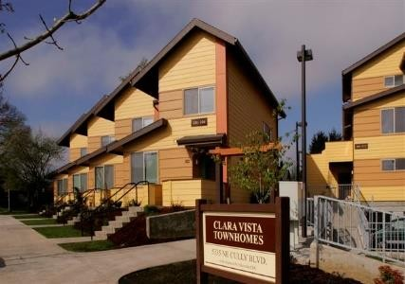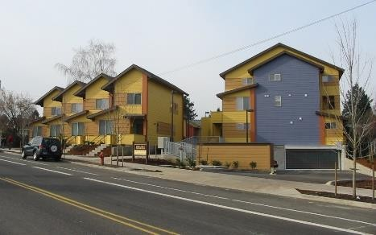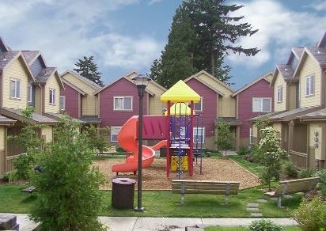

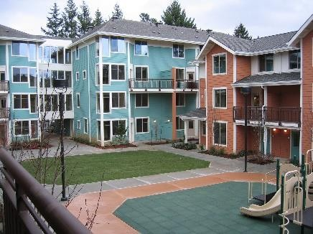
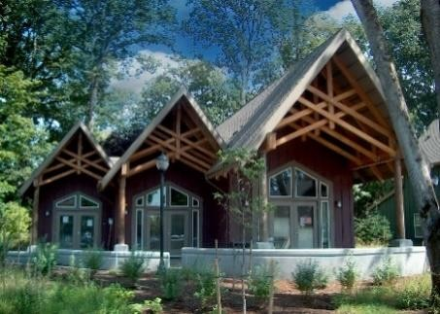
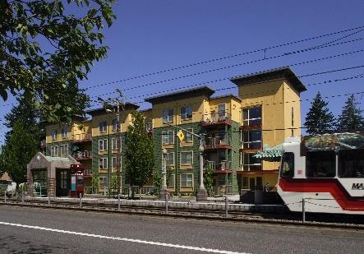

1750 SW Skyline Blvd., Suite 105 Portland OR 97221
WA GSIBUBI810KO o 971.407.4436 f 971.407.4440 ESB #12728 OR CCB223463 MBE #12728

The following three projects represents GSI Builders’ current work in the affordable and multi-family markets;

MLK 5733 Affordable Housing
This project consists of 93 units of affordable housing geared toward seniors and consists of 4 stories of wood framed units over a ground floor concrete podium and is a total of 60,670 gsf. The project is located at 5733 Martin Luther King Blvd. The ground level will consist of community space, laundry, bike storage and a small, covered parking area. Level 2-5 will have typical interior finishes, vinyl windows and composite metal exterior skin. The roof level will have a small gathering area and a large collection of solar panels. The project is funded thru OHCS LIHTC and is currently in the design development/pre-construction phase with an estimated start date of June 2021. The project team has a goal of 30% to 40% MBE/WBE/ESB participation.

Currently several GSI personnel are working on this project including Alex, Lina, Steve, and Christa Griffiths (project manager), Joe Abbett(superintendent) and Paul Nellany(estimator).

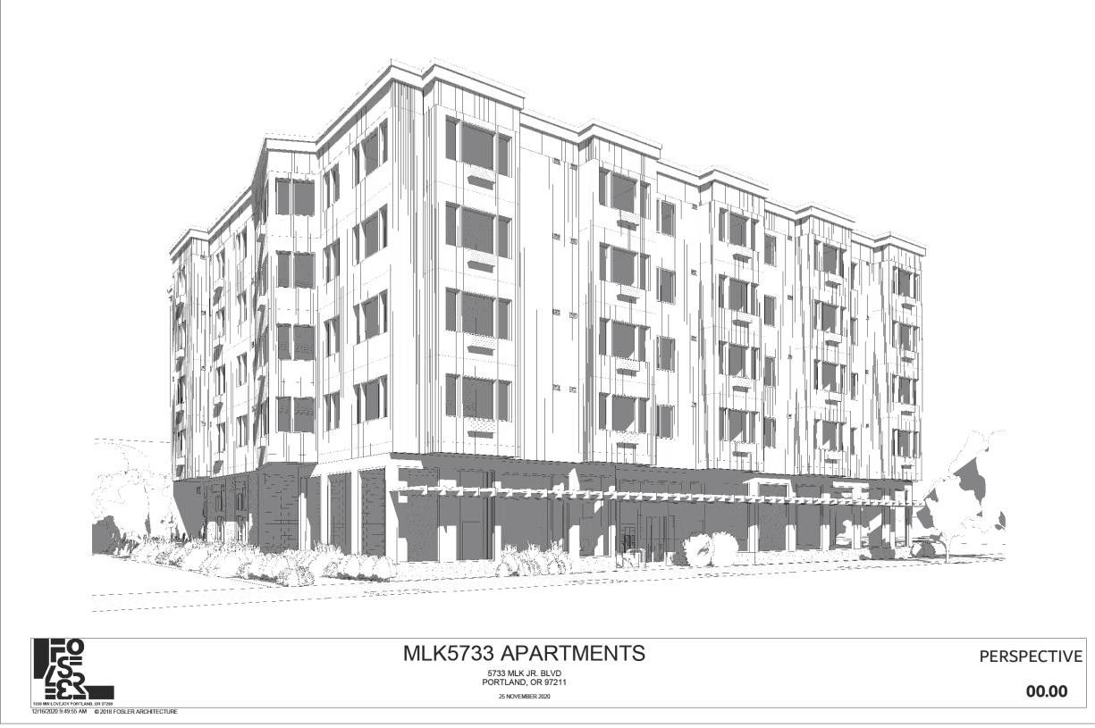

1750 SW Skyline Blvd., Suite 105 Portland OR 97221
WA GSIBUBI810KO o 971.407.4436 f 971.407.4440 ESB #12728 OR CCB223463 MBE #12728

Maryland Apartments
This project consists of 18 units of market rate multi-family housing and consists of 3 stories of wood framing with a flat roof and is nearly complete. All units are accessible from 2 exterior stairways and contains 10,158 gsf. The project is located at 6310 N. Maryland Ave. All units have standard fixtures and finishes with vinyl windows and a Hardi/wood/metal exterior skin. GSI team member include Christa Griffiths as project manager, Joe Abbett as oversite construction manager and Dan Boice as project superintendent. The GSI team has stayed on schedule and completing the project on budget with minor change orders.
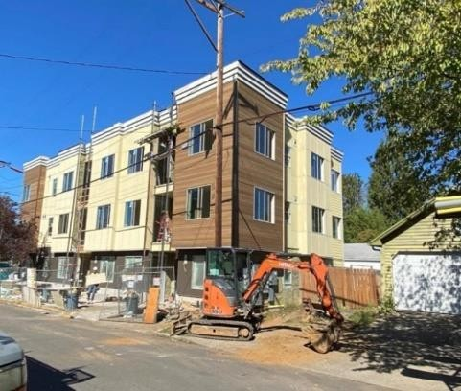
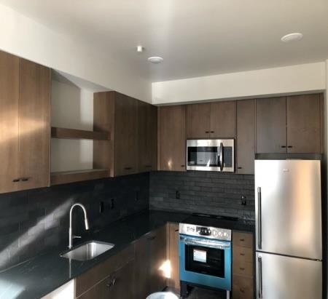
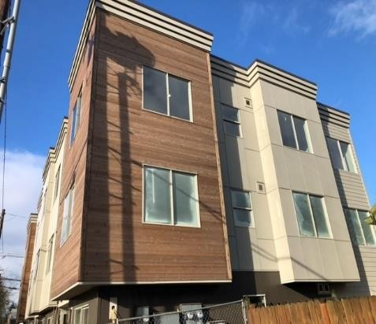
2316 N Vancouver Apartments
This project consists of 18 units of market rate multi-family housing and consists of 3 stories of wood framing with a pitched roof system. All units are accessible from 2 exterior stairways and contains 10,150 gsf. The project is located at 2316 N Vancouver Ave. All units have standard fixtures and finishes with vinyl windows and a Hardi/wood/metal exterior skin. Alex and Steve have general ownership oversite of the project guiding it thru design development and pre-construction. Our project team will include Christa Griffiths as project manager, Joe Abbett as oversite construction manager and Dan Boice will be the project superintendent

GSI Builders has had a long and successful history with affordable housing in Oregon and the Northwest and is actively pursuing several possible projects. We are in active discussions with our past client, Hacienda CDC, regarding their planned Clara Vista Apartment Redevelopment project. This ambitious project envisions a phased development currently slated to be 3 to 4 projects consisting of approximately 100 units each.

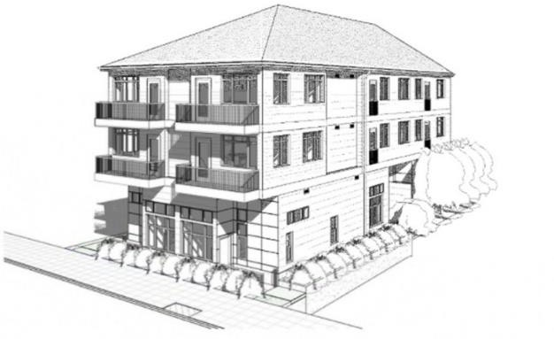

1750 SW Skyline Blvd., Suite 105 Portland OR 97221
WA GSIBUBI810KO o 971.407.4436 f 971.407.4440 ESB #12728 OR CCB223463 MBE #12728

Upcoming Projects
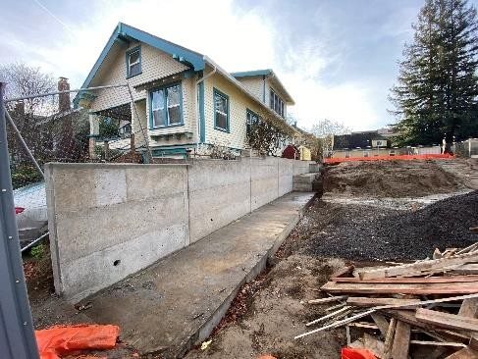
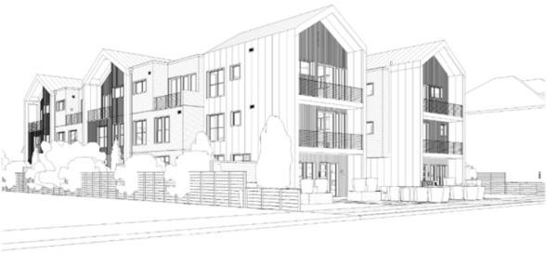
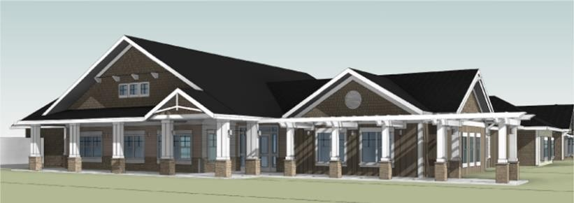

Past Projects
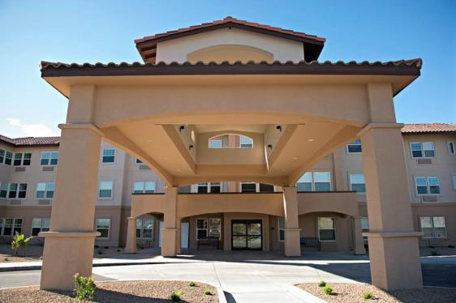
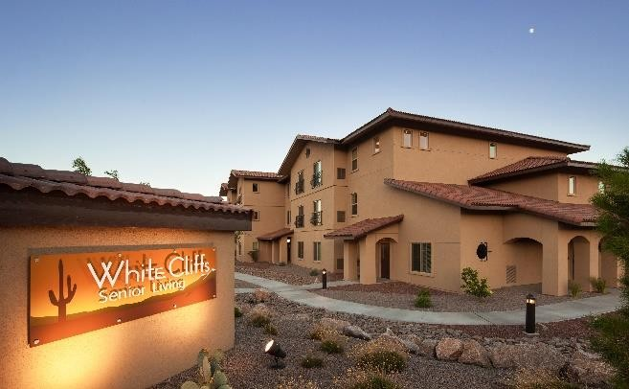
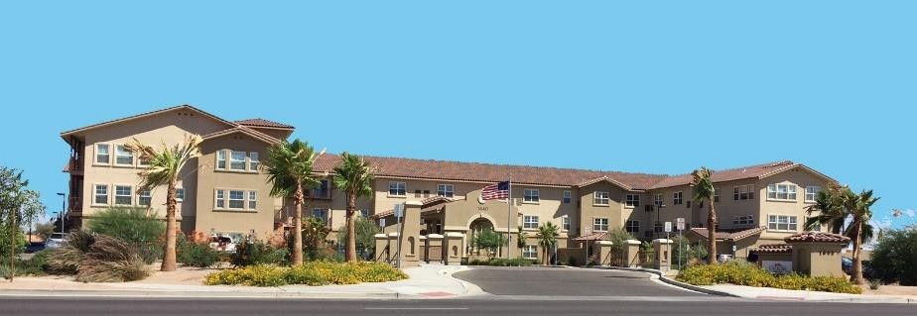

1750 SW Skyline Blvd., Suite 105 Portland OR 97221
WA GSIBUBI810KO o 971.407.4436 f 971.407.4440 ESB #12728 OR CCB223463 MBE #12728

Project Approach / Staffing & Scheduling

We understand that development brings many risks to the entire team. We believe the overall project schedule provides adequate time for the entire team to bring everyone’s strengths and expertise to the table to produce the best housing solution for all Elmonica residents. To that end, GSI Builders is committed to;

- Meet all project milestones.
- Bring valuable experience with building methods, products and systems.
- Provide accurate cost estimating during funding application, schematic design, design development and final design.
- Provide accurate and ongoing schedule development.
- Bring years of experience in value engineering.
- Provide trade input on best practices regarding building envelope systems.
- Develop additional connections with community partners for minority contracting and workforce development plan including promotion of new subcontractors and vendors with training and apprenticeship.
- Meet or exceed OMWESB goals.
- Participate in all Owner/Architect/Contractor meetings.
- Deliver the Elmonica Affordable Housing Development on Time and within Budget.

GSI is committed to providing all necessary resources and staffing during the preconstruction period, construction and warrantee. Alex, Steve and Lina will be involved during the preconstruction phase as will Christa Griffiths as project manager, Joe Abbett as construction manager and Paul Nellany as senior estimator. Resumes for proposed GSI team members are attached.

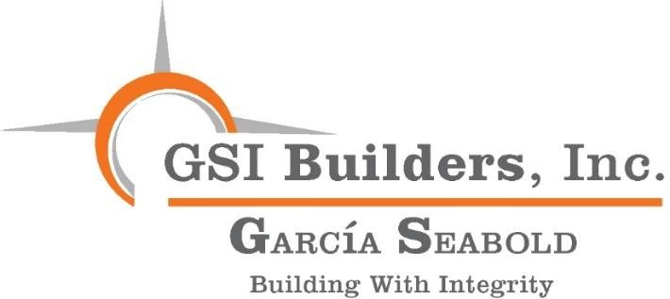

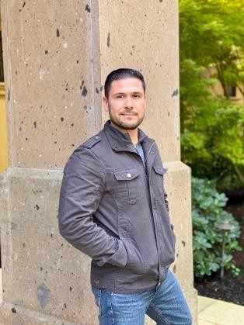
Alex C. Garcia Seabold, President

Alex is an emerging leader in the local construction industry. He is a third-generation commercial contractor and has had the benefit of being exposed to the construction industry his entire life, possessing over 15 years of direct experience in the field.

Portland, Oregon As President of GSI Builders, Inc., Alex relies on a leadership-by-example approach that includes integrity, high standards and a strong work ethic. He has a proven ability to communicate with diverse clients and business cultures to secure trust, understanding and confidence in delivering successful projects. The execution of quality projects is the primary focus of GSI Builders. With a committed group of highly accomplished professionals who, are prepared to go to work to deliver high quality projects on time and within budget, GSI Builders is proud to have them on the Team.

Performance and knowledge of commercial construction principles and practices are the strong suit and base of GSI Builders. Together, with his Father and business partner, Stephen C. Seabold, they have a combined experience of over 40 years in the local construction industry. Individually, they each have a proven track record in the Portland area and surrounding markets of trustworthy performance in the field. Alex’s Mother and business partner, Lina Garcia Seabold, also brings experience as well as a perspective unique to the Latinx and BIPOC community and is a valued member of our Team. Lina has maintained a high profile in the Latino community in Oregon for years and is a respected Leader. With Alex at its helm, GSI Builders will continue to build on those valuable relationships in the Latinx and BIPOC community.

GSI Builders’ development experience in the affordable and senior housing market (nationwide) speaks volumes to the level of competence in providing quality construction services. Major projects have been completed successfully by maintaining positive relationships with Developers, Clients, Sub-Contractors, Architects, Consulting Engineers, Inspectors, Internal Staff and community organizations.

GSI Builders’ background includes, but is not limited to, multi-family housing, affordable housing, commercial, industrial, retail, tenant improvements and senior housing, including independent living, assisted living and memory care.

Alex’s years of education and training at Oregon State University and Portland State University
focusing on Economics and International Finance, prepared him for his professional career.

In 2015, Alex founded his first business, Seabold Venture, LLC. As owner of a Jimmy Johns Gourmet Sandwich franchise, in Cornelius, Oregon, he has been able to expand his experience as an

independent Business/Owner Operator. From Customer Service, Inventory Control, hiring and firing and maintaining relations with employees in such a volatile market with regulatory challenges placed upon him has only improved his expertise and business acumen.

Alex’s background of over 15 years in the Commercial Construction market has given him a skill set that he has been professionally trained in and has executed firsthand. Alex is fully prepared to become of the new emerging leaders in the construction industry in Oregon.

Current Projects

Maryland Apartment
18 units - 3 story wood framed project Approximate Value: $2,010,000 Flanders Townhouses
6 units - 3 story wood framed project Approximate Value: $1,550,000 2316 N. Vancouver Apartments
18 units - 3 story wood framed project Approximate Value: $2,150,000 Washington County Health & Human Services TI
Build out and renovation Approximate Value: $296,462

Past Projects

Laurel Parc Retirement & Assisted Living - Bethany, OR
181-units New-Construction Approximate Value: $26,000,000 Merlo Station - Beaverton, OR
New construction project with 128 units Approximate Value: $13,000,000 Radiant Senior Living - Portland, OR
6 ALF/MC Projects, Tenant Improvements, including Fire & Life Safety upgrades Approximate Value: $75,000

Rosewood Park, IL/ALF - Hillsboro, OR
Tenant Improvements Approximate Value: $600,000
Cherry Park Senior Living - Troutdale, OR Conversion from IL to ALF and MC Approximate Value: $1,500,000,0000

MLK 5733 Affordable Housing
93 units with concrete podium, 4 floors of wood framing
Approximate Value: $13,250,000

Sacramento Condominiums
9 units - 3 story wood framed Approximate Value: $3,150,000
Washington County Conference Center TI Build out and renovation of showers and lockers
Approximate Value: $661,873

Clara Vista Affordable Housing - Portland, OR
Various Upgrades
Approximate Value: $1,000,000

Baycrest Senior Housing - Coos Bay, OR
Fire & Life Safety Upgrades Approximate Value: $500,000

Gresham Multnomah County Library - Gresham, OR
Tenant Improvement minimal shutdown Beaverton Library - Beaverton, OR Tenant Improvement, 8,000 sf. Build-out Rain Drops Night Club - Grand Ronde Casino
Tenant Improvements
$600,000

Jimmy John’s Gourmet Sandwich Stop - Cornelius, OR
Tenant Improvements Approximate Value: $475,000

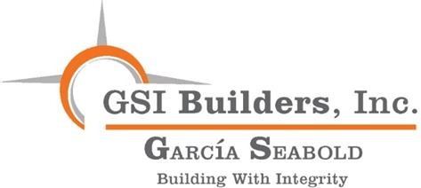
Lina Garcia Seabold, Owner/Secretary
Lina Garcia Seabold brings over 30 years’ experience in the construction industry in both the public and private sectors. Her experience in the construction industry was acquired through contract management, contract administration, small business advocacy and human relations training, all of which helped her gain real world knowledge and expertise needed to facilitate transformative change in professional lives, businesses, and organizational culture change initiatives.

Among her leadership roles, Lina’s experience includes work on two design/construction phases of the Tri-Met Light rail Projects (Eastside and Westside) where she administered the Disadvantaged Business Enterprise (DBE) Program. In this capacity, she worked with national construction companies bidding on large and small scale federally funded construction projects working toward meeting specific diversity goals. This effort led to record-breaking heights of participation and support for small businesses especially minority and women-owned businesses who had historically been underserved. She identified and developed contracting, mentorship and workforce development efforts for local construction industry companies in the Pacific NW. Lina went on to work on legislation for the State of Oregon’s First Minority Business Advocate in the Governor’s Office and served in that initial role. In this position, she oversaw the certification process for Minority, Women and Emerging Small Businesses and advocated for those businesses by bringing them together with key procurement representatives at Federal, State and local levels. Lina has a passion for bringing diverse voices to the table to realize common goals and has dedicated much of her professional career to the goals of Diversity, Inclusion and Equity.

In terms of the private sector, Lina is part owner of Garcia Seabold Investments, LLC, which has managed several Senior Housing facilities that provide independent, assisted and memory care services to Seniors in the Western Region, i.e., Cornell Estates, Rosewood Park, Rosewood Specialty Care, Washington Gardens.

In her role at GSI Builders, Lina is involved in the executive day to day management of the company overseeing marketing, human resources, finance, COVID-19 health and safety issues, contract administration, minority contracting/workforce plans and general administration.

One of Lina’s greatest professional joys has been serving on the Virginia Garcia Memorial Foundation Board where she currently serves as the incoming Board Chair. Lina received her Bachelor of Science degree from the University of Oregon in 1974 and her family was one of the First Founding Families

of the Virginia Garcia Memorial Health Center. Much of the groundwork was done in the 1970’s and what began as a small clinic serving the local farmworker community all from a 3-car garage in Cornelius, Oregon, Virginia Garcia Health Clinic is now a 17-site Clinic serving over 52,000 low- income individuals in 62 languages. Lina maintains a high profile in the Latinx community in Oregon and Arizona and she and Steve continue to actively support several Latinx and BIPOC organizations in the local community. Lina has served on the Boards of numerous Latinx and BIPOC non-profit organizations and has been recognized as a Leader by many of those organizations. Currently, Lina sits on the LatinoBuilt Board which advocates for Latino Contractors in Oregon and the EngAGE Board which deals with Seniors and building communities for all ages through the creative arts.

Lina believes that arts build emotional resilience and coping skills and strengthens our sense of identity and community. Lina is a huge supporter of the Arts and is a practicing plein-aire painter. She Chaired the Regional Arts & Culture Council (RACC) and was responsible for the adoption of the Agency’s First Equity Plan. She also spearheaded the art gift exchange of “Hermano Mago,” an iron sculpture housed in the lobby of Portland5 Centers for the Arts. This piece of art was donated (and transported) to the City of Portland by its Sister City of Guadalajara, Jalisco, Mexico.

She remains committed to staying healthy by practicing Pilates. She loves to travel and explore towns, villages, old colonial haciendas and world heritage sites throughout Mexico and Espana. What Lina enjoys most is spending time outdoors at the Oregon Coast with her rapidly expanding family of 4 Latinx-BIPOC Grandsons: Cameron, Elliott, Mateo, and Jaden. Lina celebrates Diversity every day!

Stephen C. Seabold, Vice President

In the Fall of 2018 Steve, Lina and their son Alex made the decision to create a new commercial construction company, GSI Builders, Inc. GSI Builders, Inc. derives its beginnings from the family investment entity, GarciaSeabold Investment, Inc. which is Alex’s mother, Lina’s maiden name Garcia and Seabold. Steve is Vice President/Secretary and is primarily responsible for marketing and job development.

Prior to the Fall of 2018 Steve and his wife Lina traveled to numerous places both near and far. They also had the opportunity to spend quality time with their three grandsons, Cameron, Elliott, and Mateo.

In the Fall of 2015 Steve retired from Seabold Construction Co. Inc. Steve founded Seabold Construction Co., with his father in 1984. As acting President of the company, Steve oversaw its growth for over 30 years as it became recognized as a very successful and reputable mid-sized construction company in the Northwest. Steve’s experience included commercial, industrial, retail, renovation, multi-family, and senior housing projects. During his tenure as President, Steve managed all phases of the construction business including marketing, project development, project management, estimating, scheduling, project closeouts and the warranty period. During the last 10 years of Steve’s tenure, the company saw significant emphasis on senior housing projects including construction, development, and ownership.

Prior to founding Seabold Construction Co. Inc. Steve began his construction career in 1973 as a laborer with Moran Construction Co. He steadily advanced within the company and became Vice President of the Pacific Northwest Division of Moran. Steve was directly responsible for the development, administration, and project management of many large commercial projects in the Portland area. A few of Steve’s projects include the first generation of tenant improvements in the 200 SW Market Building and the E Wing additions to Freightliner’s Corporate Headquarters on Swan Island.

In 1976 Steve graduated from Portland State University with a degree in Business Administration. Steve also attended the University of Oregon from 1969 thru 1973 and majored in architecture and business.

CURRENT AND RECENT GSI BUILDERS INC. PROJECTS

MLK 5733 Affordable Housing – Portland, OR
93 units with concrete podium, 4 floors of wood framing
Approximate Value: $13,250,000

2316 N. Vancouver Apartments – Portland, OR
18 units - 3 story wood framed project Approximate Value: $2,150,000

Sacramento Condominiums – Portland, OR
9 units - 3 story wood framed Approximate Value: $3,150,000 Maryland Apartments – Portland, OR 18-unit Market Rate Apartments Approximate Value: $2,010,072
Flanders Condominiums – Portland, OR 6-unit Townhome Condominiums Approximate Value: $1,512,180

PAST PROJECTS
AFFORDABLE MULTI-FAMILY HOUSING

Merlo Station – Beaverton, OR
New construction project with 128 units Approximate Value: $13,000,000 Lincoln Woods – Portland, OR
3-Story wood framed affordable housing project with 71 units.
Approximate Value: $6,500,000

Hazelwood Station – Portland, OR
3-Story wood framed affordable housing project with 68 units.

Esperanza Court – Portland, OR
3-Story wood framed affordable housing project with 70 units.
Approximate Value: $6,250,000
Los Jardines Apartments – Portland, OR 3-Story wood framed affordable housing project with 43 units.
Approximate Value: $3,500,000

C-TRAN Board Room – Vancouver, WA Approximate Value: $285,000 Bohemian Asset Management – Vancouver, WA
Commercial 3,050 sf. Tenant Improvement Approximate Value: $345,000

Wood St. Fire Training Tower – Hillsboro, OR
City of Hillsboro – Steel Structure & Concrete Approximate Value: $885,000

WSP DNA Laboratory TI – Vancouver, WA
Crime Lab Build-out Approximate Value: $514,000 Hacienda CDL – Portland, OR
Miscellaneous renovation to corporate office

Clara Vista TownHomes – Portland, OR 3-Story wood framed affordable housing project with 44 units.
Approximate Value: $3,740,000

Midland Commons – Portland, OR
- Story wood framed affordable housing project with 46 units.
Approximate Value: $3,700,000

Villas de Mariposa – Portland, OR
- Story wood framed affordable housing project with 70 units.
Approximate Value: $5,950,000
Jose Arciga Apartments – Forest Grove, OR Wood framed affordable housing project on 2 separate sites with 50 units.
Approximate Value: $3,750,000

Canyon East – Madras, OR
- Story wood framed 24 farm worker housing project with 20 units.
Approximate Value: $2,250,000

Additional Representative Affordable Multi-Family Projects:

PROJECT UNITS
Kauffman Townhomes – Vancouver, WA 20 Kelly Place Apartments – Gresham,OR 20
Casa Lomas – The Dalles, OR 20
Casa Verde Apartments – Canby, OR 28
Douglas Meadows – Portland, OR 08
Oleson Woods Apartments – Tigard, OR 32
Providence Place – Salem, OR 67
PROJECT UNITS
Sandy Vista Phase II – Sandy, OR 44
Songbird Village – Albany, OR 48
Lents Village – Portland, OR 63
Cherry Park Plaza – Troutdale, OR 82
Pueblo del Rio – Roosevelt, WA 20
Rockwood Landing – Portland, OR 36
Grand Ronde Tribal Housing - OR 36
Grand Ronde Tribal Housing Ph2 72

SENIOR HOUSING

White Cliff Senior Living – Kingman, AZ
- Story 97,000 sf. wood framed construction with 77 Assisted Living units and 30 units of Memory Care.
Approximate Value: $11,100,000

Summit Senior Housing – Kearns, UT
3-Story 85,000 sf. wood framed construction with 81 units of Assisted Living and 36 units of Memory Care.
Approximate Value: $11,000,000,000 Joshua Springs Senior Housing – Bullhead City, AZ
3-Story 92,000 sf. wood framed construction with 98 units of Assisted Living.
Approximate Value: $11,400,000

Avamere Senior Housing – Bethany, OR
3-Story 85,000 sf. wood framed construction with 74 units of Assisted Living and Memory Care.
Approximate Value: $4,500,000
Laurel Park Senior Housing – Bethany, OR 3-Story 85,000 sf. wood framed construction with 183 units of independent and Assisted Living units.
Approximate Value: $25,500,000

Catalina Springs Memory Care – Oro Valley, AZ
Single story, approximately 26,700 sf. wood framed construction with 56 units.
Approximate Value: $4,900,000 Arbor Oaks Terrace Memory Care – Newberg, OR
Single story wood framed building with 52 units
Approximate value - $3,500,000 Washington Gardens Memory Care – Tigard, OR
Single story wood framed building with 48 units
Approximate value - $3,750,000
Joshua Springs Senior Living – Bullhead, AZ 3 story wood framed building with 74 units of assisted living and 30 units of memory care.
Approximate value - $8,000,000

Canyon Valley Memory Care – Green Valley, AZ
Single story wood framed building with 52 units.
Approximate value - $3,950,000

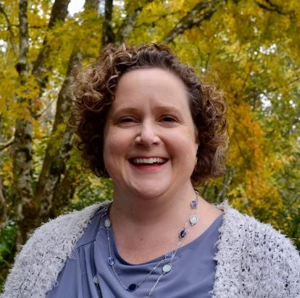
CHRISTA GRIFFITHS
Contracts/Project Manager

CURRENT RESPONSIBILITIES

As Contracts Manager Christa Griffiths oversees projects from inception to occupancy, ensuring all work is completed on time and within budget. Christa works on a wide variety of projects, from office developments to senior housing, schools, tenant improvements, and retail. She is just as comfortable working on a single scheme as working on several ones.
Christa is the first point of contact for all clients, subcontractors, and site managers, for the duration of the contract. Christa brings her experience and education to the execution and oversight of all contracts with a keen eye for monitoring project budgets, scheduling, and overall project integration of Owner and Contractor activities. She helps to resolve disputes and identify areas for improvement in GSI’s contracting processes.

CAREER SUMMARY
Christa Griffiths comes to GSI Builders with 25 years of varied construction experiences. Rising through the construction ranks from purchasing, estimating, accounting, contracts, field engineer, and project manager; Christa’s strength lies in her flexibility to manage multiple projects, as well as multiple tasks. She has worked with Steve and Alex previously for 12 years.

EDUCATION
2010 Project Management Certification PSU OSHA 30Hour, Safety

LEED Green Associate
AAS Science Construction Management

Christa also is committed to community activities including time as school board member and chair, neighborhood committee member, HSBA handicap ramp building, and food pantry volunteer.

PROJECT HIGHLIGHTS
WSP DNA Laboratory TI – Vancouver, WA
Crime Lab Build-out, 2150 sf

Summit Senior Living – Salt Lake City, UT
Assisted living, and Memory care 98,000 SF

Catalina Springs – Oro Valley, AZ
Memory Care, 56 Beds 28,000 Sq. Ft.

JOSEPH ABBETT
Construction Manager
CURRENT RESPONSIBILITIES
Joe is currently GSI Builders’ Construction Manager with oversight of all Field Operations. Joe is a self-motivated individual with a knack for solving difficult project related issues. Utilizing over 35 years of experience in the construction industry, Joe meets with building owners and tenants to discuss build-out specifications and improvements. He mediates between landlords and tenants to find workable solutions that appeal to both parties. Joe has also assisted in the renovation and construction of a HUD 811 project.

CAREER SUMMARY
Joe is a deadline-driven Construction Superintendent who oversees construction projects and acts as a link between various project parties. He leads and manages the onsite construction team and oversee all work onsite. Joe maintains orderliness on site, as well as ensure compliance with safety regulations are followed. Joe ensures quality standards are met, and all equipment and materials are always available onsite. Joe liaises with inspection authorities regarding approvals.
Joe ensures success by seeing to it all projects are complete on time and within budget, and never compromise on quality. Joe is a strong leader, proactive, and performs well under pressure
Joe previously worked with Steve and Alex for over 12 years at Seabold Construction.

Education
1984 – 1988 Journeyman Certification, United Brotherhood of Carpenters

PROJECT HIGHLIGHTS
Emerald Pointe – Keizer, OR

New construction of wood frame 143-unit retirement facility
Lincoln Woods Apartments – Portland, OR Section 42 low-income housing w/internal office and community space

Cherry Park Plaza – Troutdale, OR
82-unit 3 story independent senior retirement community w/congregate facility Washington Gardens Memory Care – Tigard, OR
Single story wood framed building with 48 units Approximate value - $3,750,000

Kateri Park Apartments – Portland, OR
(Assistant Superintendent)
50 units of multifamily housing for very low- income individuals and families – includes environmentally Green-building elements in design and construction

Arbor Oaks Terrace Memory Care –
Newberg, OR
Single story wood framed building with 52 units
Approximate value - $3,500,000

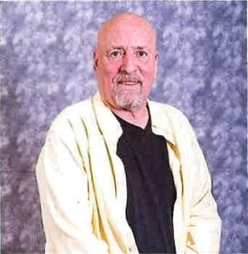
PAUL NELLANY
Senior Project Estimator

CURRENT RESPONSIBILITIES
Paul is Senior Project Estimator at GSI Builders and handles all project estimates and bidding.
Paul’s primary focus is bidding private and public projects, including the accurate and comprehensive process of bid preparations, submittal and follow up. Paul has a wide range of talent and works
well with teams in all fields of construction management. Paul gladly welcomes challenges in which he and his team can produce completed projects that will set a tone and precedent for future endeavors.

CAREER SUMMARY
With more than 30 years in the construction industry, Paul has managed and directed all aspects of the development process from estimating, inception of the project, to close out and turn over to the client. These projects have included $500 million in school and university construction, $ 368 million in hospital construction, $455 million in commercial projects, $165 million in multi-family housing, $220 Million in restaurant construction and $120 million in Theater Construction.

EDUCATION
Union Trained Carpenter
University of California, Santa Barbara, CA Business Management Cal Poly San Luis Obispo, B.S. Construction Management

COMMUNITY ACTIVITIES / VOLUNTEER EXPERIENCE:
Teach computer science and application use. Donate time to Hospice of the Valley, Salvation Army, and Veterans Administration.

PROJECT HIGHLIGHTS
Commercial

West Gate Shopping Center – San Jose, CA Complete renovation and build out Approximate Value: $43,000,000

Hi-Tech
Solectron – Fremont, CA
700,000 sq. ft. facility, including site work, offices, clean rooms, processing room, point to point manufacturing facility
Approximate Value: $125,000,000

Bridgepoint Shopping Cntr. – San Mateo, CA
Complete renovation and build out Approximate Value: $22,000,000

Maxtor – Scotts Valley, CA
200,000 sq. ft. facility, including site work, offices, clean rooms, processing room, point to point manufacturing facility
Approximate Value: $128,000,000
Diversity, Equity and Inclusion Plan for
Minority Contracting and Workforce Development

We remain committed to Diversity, Equity and Inclusion and have always strived to meet or exceed all our goals on all our projects. In years past, our MBE goals were typically met at 20%.
We utilized the State’s Directory of Certified Firms and relied on existing relationships with BIPOC community organizations for outreach and referrals. Examples of past affordable housing projects include Merlo Station, Villa de Mariposa and Lincoln woods where 20% OMWESB goals were consistently met or exceeded; a diverse workforce was always present at all our jobsites.

We have taken a pause of 6 years in our transition from the former company to what is now GSI Builders, Inc. We have re-emerged with new family Ownership as a Latino-Owned company and certified by the State as MBE/ESB. GSI Builders has renewed energy and interest and commitment to DEI and passionate about making a direct positive impact in the construction industry where MBEs/BIPOC subcontractors, vendors and trained workers are concerned. Heretofore, we have had the benefit of utilizing an outstanding cadre of Latino subcontractors, but we will aggressively strive to include subcontractors from other BIPOC communities. As a General Contractor, we feel we have a responsibility to bring other smaller subcontractors along so they can gain valuable experience and get a toehold in the industry. After our sabbatical and with Alex at its helm, GSI Builders has re-established contact with some of our former Latino and BIPOC community members and has sought to aggressively establish new ones. Because we are now Latino-Owned, GSI Builders is able to independently establish its own policies and follow its own direction towards involving and integrating BIPOC members in all its projects. We are committed to meeting or exceeding a 25%-30% OMWESB participation at Elmonica. Currently, in addition to utilizing the State’s COBID Directory of OMWESB certified firms, GSI Builders is a Patron/Sponsor/Member of the following Latinx and BIPOC organizations, which we feel we can call on to meet our outreach plan:

LatinoBuilt; Native American Youth Association (NAYA); Latino Network, Oregon Native American Chamber (ONAC); Metropolitan Hispanic Chamber of Commerce (HMCC) ; POIC ; National Association of Minority Contractors (NAMC) ; Centro Cultural ; Virginia Garcia Memorial Foundation

With respect to workforce training, it is our belief that we need a skilled and well-trained workforce and that we need to work with our educational institutions such as Portland Community College and BOLI in order to accomplish that goal. GSI Builders is working with LatinoBuilt, POIC and NAMC to begin looking at existing pre- apprenticeship programs as well as possibly establishing a Pilot Construction Training Program to include Summer Interns as well as a Match-Making Mentoring Program for local students and residents. As part of our outreach plan and in the early stages of construction we intend to seek out smaller contractors and vendors and provide them with opportunities and training. We plan to involve our major subcontractors and partners in this effort (i.e., Architects, Artists, Electrical, HVAC, Plumbing, Framing, Drywall, etc.) This could be specifically reserved and targeted toward local Latinx and BIPOC members and residents. Given the current demographics with the Latinx community being the largest in Beaverton, we have entered into preliminary discussions with LatinoBuilt for technical assistance for small businesses on the Elmonica Project and look forward to working with them.

GSI Builders is passionate about equity issues in the construction industry and the importance of best practices. We understand the history of racial injustice and have lived it. We believe in being inclusive and always having a respectful construction workplace environment. We also believe in building and maintaining important partnerships with existing institutions as well as the business community in Portland. In our experience, these partnerships will empower the local Latinx-BIPOC community long term. GSI Builders is poised to serve as that bridge and give these smaller Latinx-BIPOC businesses and residents a hand up.

1750 SW Skyline Blvd., Suite 105 Portland OR 97221
WA GSIBUBI810KO o 971.407.4436 f 971.407.4440 ESB #12728 OR CCB223463 MBE #12728

OMWESB Certification

Business & Contact Information
BUSINESS NAME GSI Builders Inc.
OWNER Mr. Alexander (Alex) Seabold
ADDRESS Map This Address
1750 SW Skyline Blvd. #105
Portland, OR 97221
PHONE 971-407-4436
FAX 971-407-4440
EMAIL alexseabold@gsibuildersinc.com
WEBSITE N/A
ETHNICITY Hispanic
GENDER Male
COUNTY Multnomah (OR)
Certification Information
CERTIFYING AGENCY State of Oregon
CERTIFICATION TYPE MBE - Minority Business Enterprise
CERTIFIED BUSINESS DESCRIPTION Commercial General Contractor Level 1, new construction and remodel
Commodity Codes
Code Description
NAICS 236220 Commercial and Institutional Building Construction
NIGP 90924 Building Construction, Commercial and Institutional Additional Information
GENERAL LOCATION Willamette Valley
ESB TIER LEVEL Tier 1
OR CERT ID 12728

1750 SW Skyline Blvd., Suite 105 Portland OR 97221
WA GSIBUBI810KO o 971.407.4436 f 971.407.4440 ESB #12728
OR CCB223463 MBE #12728

References
The GSI Builders, Inc. team has over 75 years of collective construction experience in the Pacific Northwest and Western States. That experience includes work in affordable multi-family housing, farm worker housing, market rate multi-family housing, senior housing including independent, assisted and memory care, commercial, industrial, retail, renovation, and tenant improvement markets. We have compiled a list of references reflecting that depth of experience from our core team.
Owners & Developers

Ernesto Fonseca Executive Director Vasili Rozakis Owner  George Schmidbauer Owner/Developer Amber Schulz-Oliver  Executive Director | Hacienda CDC 503-595-2111 efonseca@haciendacdc.org Diamond Investment Group 503-970-8645 V@rozakis.com  MLK 5733 Project 530-351-1142 georgeschmidbauer@gmail.com  Affiliated Tribes of Northwest Indians Economic Development Corporation
Dan Steffey | 971-678-9721 amber@atniedc.com
Principal Ron Ziebart  Owner/President | JDSCO, LLC 503-309-7643 jdanielsteffey@jdscobiz.com  Link Senior Development 503-363-4636
Yoni & Neiv Schwartz | ziebart@linkseniordevelopment.com
Principals Max Sass | One 45 Group 702-285-7009 yoni@one45group.com neiv@one45group.com
Owner UHI Investments Rick Dillon  Owner Avamere Health Services, Inc. |  | 702-499-1530  503-570-3405 | m.sass@uhi.investments  rdillon@avamere.com
Architects & Engineers
Steve Fosler
Architect Owner Fosler Portland Architecture Chuck Archer  Associate LRS Architects |  | 503-241-9339  503-221-1121 | steve@foslerarchitecture.com  carcher@lrsarchitects.com
Michael Barrett  Principal HBX Studio |  | 503-968-9374 | michael@hbx-studio.com
Gunnar Langhus  Senior Associate Ankrom Moisan Architects |  | 503-245-7100 | gunnarl@ankrommoisan.com
Andy Borgerding  Project Manager Fosler Portland Architecture |  | 503-241-9339 | andy@foslerarchitecture.com
Trade References
Brett Egdorf  Estimator Timberland, Inc. |  | 503-329-1823 | brett@timberlandframing.com
Marcelino Marquez
Owner Marquez Contracting Corp. 971-217-2978 marquezcontracting@gmail.com Jr Barreras
Owner Northwestern Roofing and Sheet Metal, Inc. 503-849-8502 jr@nwrasm.com Eric Castillo/Maria Cawley
Owners Freedom Drywall 503-329-6958 freedomdrywall09@gmail.com

Chuck Mcclaugherty
Project Manager Bear Electric 503-678-1355 ext. 126 cmcclaughterty@bearelectric.com Oliver Raab
Senior Vice President Jet Industries, Inc. 503-363-2334 Oliver.r@jetindustries.net

Legal

Dustin Klinger
Partner Thede Culpepper 503-416-6148 Dustin.klinger@thede-culpepper.com

Accounting

Candy Dunbar
CPA & Partner Jarrard Seibert, Pollard & Co. 503-723-7600 candy@jspcpas.com

Banking  Sabina Trnjanin  Relationship Manager/Asst. VP | KeyBank | 503-790-7639 | Sabina_trnjanin@keybank.com
Dinah Pascual Branch Manager | KeyBank | 503-626-3910 | Dinah_W_Pascual@KeyBank.com
Insurance & Bonding
Diane Durnin
Director of Non-Profit Division JD Fulwiler & Co. Insurance 503-977-5605 ddurnin@jdfulwiler.com Blaine Williamson
Senior Vice President Markel Surety 503-803-4448 blaine.williamson@markel.com

Attorney at Law

James M Walker
Partner Miller Nash Graham & Dunn LLP 503-224-5858 james.walker@millernash.com

